CAS PY 106

Pre-lecture note 9

1. Current, and unit for Current
2. Unit for current are charge over time (C/s), but known as ampere (A), called amps

I = delta Q/ delta t

1. Another representation is rate of flow (current)
2. How battery works
3. Battery is entire electron manufacturing process
4. It does not create electrons
5. Chemical reaction frees up electrons at the negative electrode. These flow through the circuit to positive electrode, giving up energy along the way, where another chemical reaction recycles the electrons (and binds them into waste products)
6. The electrodes are used up in this process and waste products are produced. This is why batteries run out.
7. In rechargeable battery, chemical reactions are run in reverse to repair the electrodes. That can only be done so many times
8. Fuel cells are like batteries where raw materials are continually added, and waste products are constantly removed
9. Resistance and Ohm’s law
10. Electric devices, such as toaster elements and light bulb filaments, resist the flow of charge and are called resistors
11. If we connect wire to battery, charge does flow (there will be a current in the wire)
12. The flowing charges generally have difficulty passing through the wire, due to electrical resistance, which is measure of how difficult it is for charges to flow through the wire
13. The resistance of a resistor is ratio of potential difference across it to current through it:

Ohm’s Law: R = V/I or V = IR or I = V/R

V is potential difference/voltage

I is the current

Unit for resistance is ohm

1. Ex) circuit has 5 V and current of 1amp

Resistance is 5 Ohms

1. Current increases as battery voltage is increased and resistance of resistor is decreased
2. How to think about Ohm’s Law
3. When battery is connected to resistor, how much current does battery provide?

I = V/R

1. Electrical resistance
2. Many materials have constant resistance, and are said to be ohmic devices

V/I = R = constant (resistance is constant)

1. The resistance, R, is a measure of how difficult it is for charges to flow.
2. The resistance of ohmic device (like a wire) depends on its length L, cross sectional area A, and resistivity p, number that depends on material

R = p \* L /A

1. 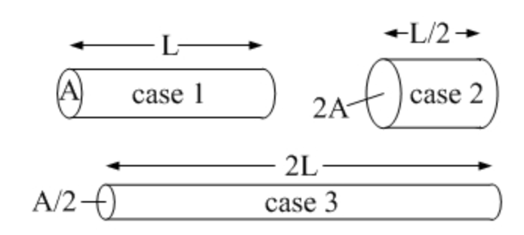
2. Ranking by resistance:
3. Case 3 🡪 R = 2L/(A/2) = 4L/A
4. Case 1 🡪 R = L/A
5. Case 2 🡪 R = L/2/(2A) = L/4A
6. Resistivity
7. Resistivity (p) values cover incredibly wide range
8. 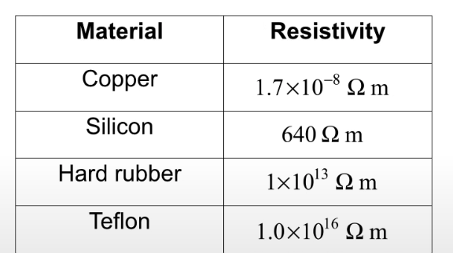
9. Temperature dependence
10. At higher temperature, atoms vibrate more energetically, making it difficult for electrons to move pat – making resistance higher with high temperature
11. However, some materials like semiconductors free more electrons to serve as conduction electrons and is associated with decrease in resistance
12. For example, light bulbs are non-ohmic because their resistance is dependent on temperature

R = p \* L / A

p = p[1+alpha \* delta T]

R = R[1+alpha \* delta T]

Alpha is temperature coefficient of resistivity

T is the temperature

1. Electrical power
2. Typical incandescent light bulb has two numbers on it: power in watts and voltage in volts (typically 120V for household electrical outlet in NA)
3. With these numbers, you can determine current through the bulb and resistance of bulb:

U = qV

P (power) = q\*V/t = q/t \* V = I \* V 🡪 P=I\*V (I is current, V is voltage)

Using Ohm’s law of V = I\*R

P = IV = I (I \* R) = I^2 \* R 🡪 P = I^2 \* R (I is current, R is resistance)

Using I = V/R

P = I^2 \* R = V^2/R 🡪 P = V^2/R (V is voltage, R is resistance)

1. Calculating resistance
2. Resistance of bulb with 40W (power) and 120V:

P = V^2/R 🡪 R = V^2/P

R = 120^2/40 = 360 Ohms

1. Measuring current
2. To measure current, we use ammeter
3. Ammeter should be placed in series with one another (usually involves breaking of circuit, so that ammeter can be included)
4. 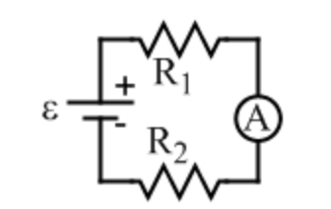
5. The figure above has ammeter indicated by circle with A in it
6. To minimize impact of adding ammeter, it should have lower resistance than the resistance of whatever you are trying to measure the current through
7. For that part of circuit, the ammeter resistance adds to the resistance of whatever it is in series with
8. Measuring Voltage
9. To measure voltage, we use voltmeter
10. Voltmeter should be placed in parallel with one another
11. 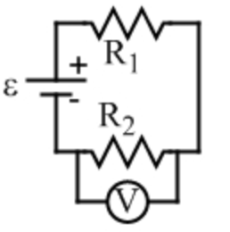
12. The figure above has voltmeter indicated by circle with V in it
13. To minimize the impact of adding voltmeter, it should have a higher resistance than the resistance of whatever you are trying to measure the potential difference across
14. The higher the resistance of voltmeter, the lower amount of current that is diverted through the voltmeter, not affecting the system